**Academic Year: 2023-24 Semester: V**

**Class / Branch: TEIT Subject: DevOps Lab**

**Name of Instructor: Prof. Sonal Jain/Prof. Neha Deshmukh**

# Experiment No. 12

**Aim: To install and configure software configuration management using Ansible.**

Ansible is an open source IT Configuration Management, Deployment & Orchestration tool. It aims to provide large productivity gains to a wide variety of automation challenges. This tool is very simple to use yet powerful enough to automate complex multi-tier IT application environments.

# Ansible Terms:

**Controller Machine:** The machine where Ansible is installed, responsible for running the provisioning on the servers you are managing.

**Inventory:** An initialization file that contains information about the servers you are managing. **Playbook:** The entry point for Ansible provisioning, where the automation is defined through tasks using YAML format.

**Task:** A block that defines a single procedure to be executed, e.g. Install a package.

**Module:** A module typically abstracts a system task, like dealing with packages or creating and changing files. Ansible has a multitude of built-in modules, but you can also create custom ones.

**Role:** A pre-defined way for organizing playbooks and other files in order to facilitate sharing and reusing portions of a provisioning.

**Play:** A provisioning executed from start to finish is called a play. In simple words, execution of a playbook is called a play.

**Facts:** Global variables containing information about the system, like network interfaces or operating system.

**Handlers:** Used to trigger service status changes, like restarting or stopping a service.

# Ansible Architecture

The Ansible orchestration engine interacts with a user who is writing the Ansible playbook to execute the Ansible orchestration and interact along with the services of private or public cloud and configuration management database as shown in figure.

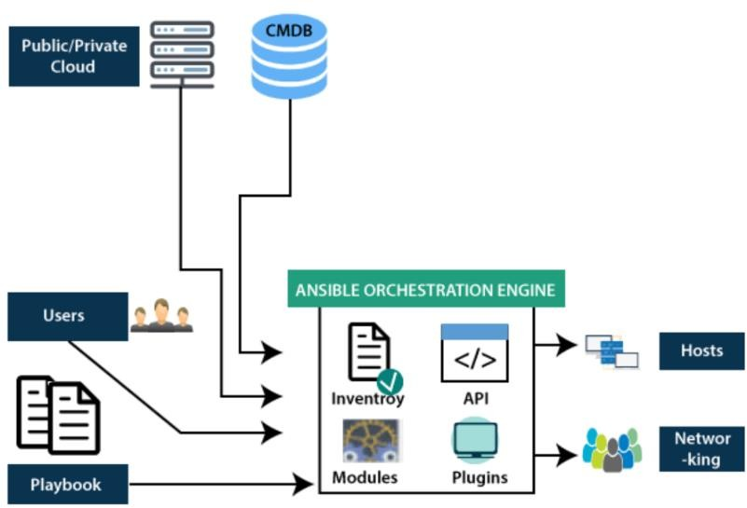

**Step1: Update the system first**

**sudo apt-get update**

**Step 2: To install ansible using following command**

**sudo apt install software-properties-common ppa:ansible/ansible**

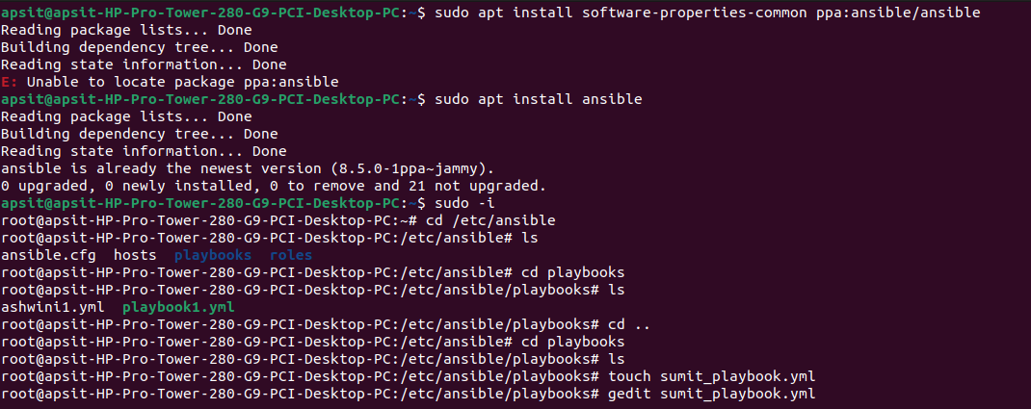**Step 3: Installing ansible**

**sudo apt install ansible**

**Step 4: do further process using root login**

**sudo su root**

**Step 5: Enter into ansible directory and create folder named as playbook**

**cd /etc/ansible/ls**

**ls**

**mkdir playbooks/**

**cd playbooks/**

**Step 6: Create playbook with anyname and keep extension as .yml**

**gedit playbook1.yml**

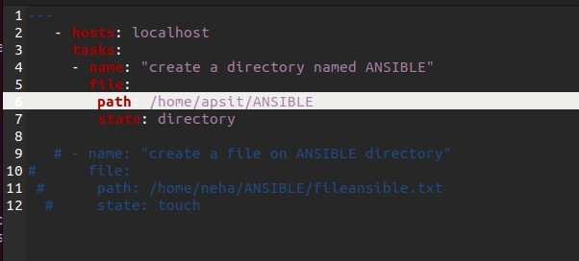

**Step 7: To run playbook script using ansible**

**ansible-playbook playbook1.yml**

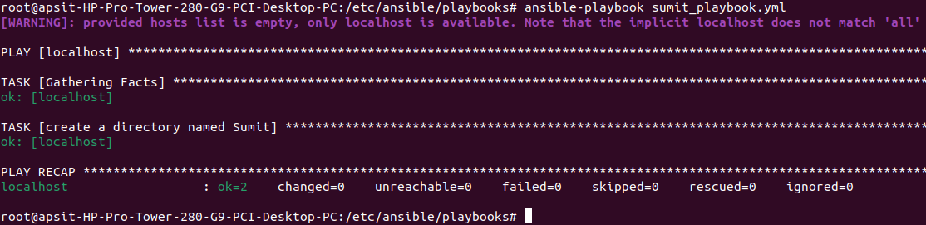

**Step8: Verify whether ANSIBLE folder has been created on given path or not.**

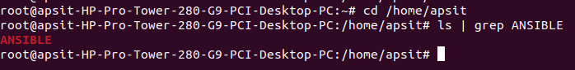

**Conclusion:-**

Thus, we have learnt about Ansible which is an automation tool built in python language and with its help we have created a directory named “ANSIBLE”.